(Title) Journal Paper Template
David M. Warsingerª, Kishor Nayar^{a*},

ª School of Mechanical Engineering and Birck Nanotechnology Center, Purdue University, West Lafayette, IN, 47907, USA
* Corresponding Author advisersemail@mit.edu
Target journal: Desalination
Target Length: 15-20 pages
Deadlines?
Outlining To do: sketch potential figures, note included equations, organize into subsections,

Abstract

Introduction

Template Features
- Automatic number updating for: section and subsections, figures, tables, and equations
- Default Headings (Word Styles) formatted for typical Journal papers (to change fonts etc to different journal styles)
- Default and section fonts of typical Elsevier submissions (Calibri)
- 4 types of automatic citations set up (BibTex4Word, Reference Manager, MS Word references, Mendeley)

How to use this document

To have numbers for sections, figures, tables, and equations that auto update, simply copy the number you want from another section. Numbers update upon seeing the print preview.

Start a paper with this document to keep the header and font formatting ¹.

Methodology

Sub heading 1

Table 2.1. Sample Table
 | Property | Source | T | S | P | Accuracy
 |  |  | (°C) | (g/kg) | (bar) | (%)
1. | Ρ | Isdale et al. & Millero et al. [3,4] | 0 – 180 | 0 – 160 | 1.01 - P_{sat} | 0.1
2. | c_{p} | Jamieson et al. [5] | 0 – 180 | 0 – 180 | 1.01 - P_{sat} | 0.28
3. | H | IAPWS 2008 [6] | 10 - 120 | 0 - 120 | 1.01 - P_{sat} | 1.5
4.. | µ_{s} | Derived: µ_{w} = g – (1000-S)*$\frac{∂g}{∂S}$

Table 1.1 shows the range and validity of a few thermodynamic properties …..
Or use: Table 2

Results and Discussion

Equations
Equations numbered by section:

$κ_{T}= \frac{1}{ρ}*{\left(\frac{δρ}{δP}\right)}_{T}= -\frac{1}{ν}*{\left(\frac{δν}{δP}\right)}_{T}$ | (3.1)
Table 3.1. Sample
$β_{P}= -\frac{1}{ρ}*{\left(\frac{δρ}{δT}\right)}_{P}= \frac{1}{ν}*{\left(\frac{δν}{δT}\right)}_{P}$ (3.2)

Equations numbered throughout document (section break right here):
$h\left(T,S,P\right)=h\left(T,S,P_{0}\right)+\int_{P_{0}}^{P}{υ*\left(1-β_{P}*T\right)∂P}$ | (3)

Don’t forget you can use cross reference to refer to tables, figures, etc such as Figure 1 or equations (in tables like (3.1) or Table 2.1 ) or with white text (as in (3.2)).

Figures
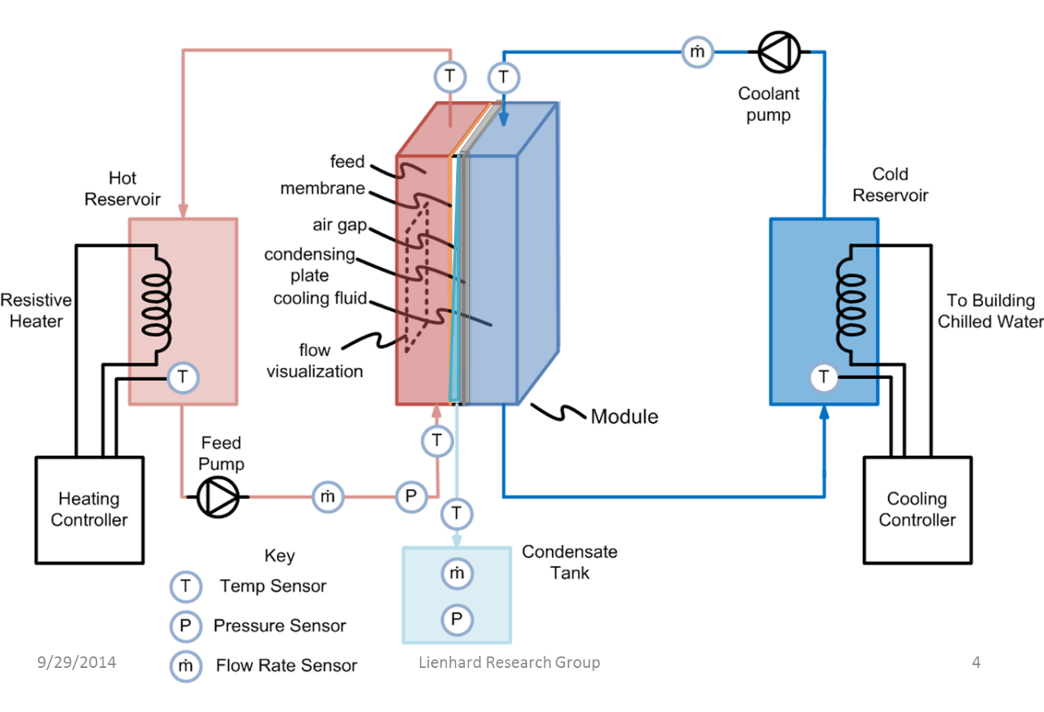
Figure 1. ² The numbering for figures can be by the total number of figures

¹

Figure 1
Fig. 18
Fig. 1

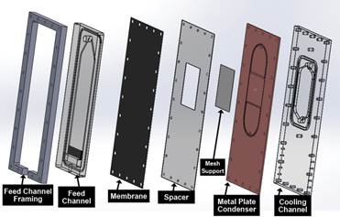
Figure 3.2. [2] Or the figure numbering can be based off the section number

Paper Planning

Conclusions
Cited fact with BibTex4Word ^{2, 3}

Cited fact with ReferenceManager [1, 2]

Cited fact with Microsoft Word references [1]

Cited fact with Mendely [2]

Acknowledgements
The authors of this template would like to thank Evan Bordt and Andrew Horning for their contributions to this work.

References

BibTex Citation

1. D. M. Warsinger, J. Swaminathan, E. Guillen-Burrieza, H. A. Arafat, and J. H. Lienhard V, “Scaling and fouling in membrane distillation for desalination applications: A review,” Desalination, vol. 356, pp. 294–313, 2015.

2. D. M. Warsinger, J. Swaminathan, , H. W. Chung, S. Jeong, and J. H. Lienhard V, “The effect of filtration and particulate fouling in membrane distillation,” in Proceedings of The International Desalination Association World Congress on Desalination and Water Reuse, San Diego, CA, USA, Aug. 2015.

3. D. M. Warsinger, J. Swaminathan, and J. H. Lienhard V, “Effect of module inclination angle on air gap membrane distillation,” in Proceedings of the 15th International Heat Transfer Conference, IHTC-15, Paper No. IHTC15-9351, Kyoto, Japan August 2014.

ReferenceManager Citation
1. J. O'M. Bockris, Fundamental Aspects of Electrocrystallization, Plenum, New York, 1967.
2. A. Brenner, Electrodeposition of Alloys, Vols. I and II, Academic, New York, 1963.

Microsoft Word Citation

[1] | D. M. Warsinger, J. Swaminathan, E. Guillen-Burrieza, H. A. Arafat and J. H. Lienhard V, "Scaling and fouling in membrane distillation for desalination applications: A review," Desalination, vol. 356, pp. 294-313, 2014.

Document Revisions
Date | Changes made
Oct 15, 2012 | Analyzed density variation with pressure using TEOS-10. Huge anomalies observed.
Oct 24, 2012 | Figured out error in units of p. Converted to gauge pressure in decibar (1 bar = 10 dbar). Revised all figures. Got good matches

